**VARANASI EXTENSION**

**DAY 1 DELHI – VARANASI (FLIGHT)**

Moring in time transfer to airport to board flight for Varanasi

Arrive in Varanasi. Meet & greet by a dnata representative at the airport who will later escort you to your hotel, where you stay for 02 nights.

**Varanasi** is probably the place in India that has the most profound impact on visitors. Formerly known as Benares, it sits on a bend of the Ganges, and its spiritual significance comes from its status as a "crossing place", where Gods and Goddesses can descend to earth. It has been a pilgrimage site since the sixth century BC; Hindus try to visit at least once in their lifetime to pray and bathe in the holy river. The Old City, a maze of tiny alleys, has several temples, including the Golden Temple - which is only accessible to Hindus - and many cows, which have traffic priority.

**Meals included: Breakfast**

**Overnight: Hotel**

**DAY 2 IN VARANASI**

Breakfast at hotel.

Early morning, enjoy a boat cruise on River Ganges. The ghats - hundreds of stone steps flanking the riverbank - are an incredible sight, particularly at sunrise when thousands of pilgrims bathe in the spiritually cleansing waters. Funeral pyres smoke on the riverbank, which is lined with colorful temples. The boat ride is one of the best ways witness the ceremonies.

Also referred to as "city of temples and learning", the culture of Varanasi is deeply associated with the river Ganges and the river's religious importance. The city has been a cultural and religious center in northern India for thousands of years. Walk through the narrow streets and alleys of Varanasi. Wandering through this maze will be fascinating; a great opportunity for photos.

After the boat ride, return to hotel for breakfast.

Later visit Sarnath. It is one of the important Buddhist centres where Lord Buddha had preached his first sermon and set in motion the Wheel of Law (Maha-Dharmachakra-Pravartan). Several Buddhist structures were raised at Sarnath between 3rd century BC and 11th century AD. Most of the ancient buildings and structures at Sarnath were damaged or destroyed by the Turks. However, amongst the ruins The Dhamek Stupa is the most distinguished one. It was built in 500 AD to replace an earlier structure commissioned by the great Mauryan king Ashoka in 249 B.C.E., along with several other monuments, to commemorate his pilgrimage there. Also visit the museum which houses a collection of valuable ancient scriptures & artifacts related to Buddhism(Sarnath museum is closed on Friday).

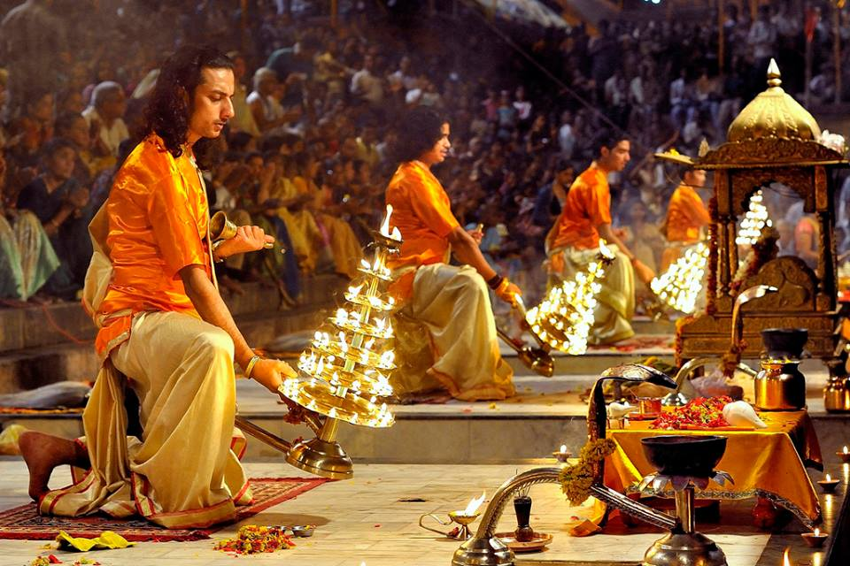Evening witness a Hindu prayer ceremony `aarthi' on the Ganges River! You will be escorted to Dhaswashmedh Ghat on bi-cycle rickshaw from where you will embark on a boat to witness the aarti for approximately 20- 30 minutes. En-route, drive past through the local bazaars. The river banks `ghats' and temples are lit with oil-lamp and candles which create a magical effect. Devotees float the oil lamps in the water as an offering to the holy river.

**Meals included: Breakfast**

**Overnight: Hotel**

**DAY 3 VARANASI – DELHI DEPART**

In the morning visit the famous Banaras Hindu University. One of the oldest educational centres of India, this university was was founded by Pandit Madan Mohan Malviya in 1917 for the study of Sanskrit, Indian art, culture and music. The university campus extends over five square kms and contains the Bharat Kala Bhavan.

Continue to New Vishwanath Temple which is Located within the premises of the Banaras Hindu University.

Also visit Bharat Mata Mandir. Opened by Mahatma Gandhi, this temple is dedicated to 'Mother India. This simple temple has a perfect relief map of India carved out of a Marble.

The tour culminates at Durga Temple. This 18th century Durga Temple is also called the Monkey Temple. It has been built in a common north Indian style with an ornate shikhara, with five segments symbolizing the elements, supported by finely carved columns.

**Later a dnata representative will escort you to airport for your flight to Delhi.**

**On arrival in Delhi, further board the flight for onward destination**

**TOUR ENDS**